DotNetNuke Translator
Version 1.00.01



Table of Contents
Introduction 2
Installation 3
Creating a Project 3
Project Settings 5
General Settings 6
Open RESX Files to edit 7
Using the Automatic Translation services 9
Creating a Language Pack 11
Dictionary 12
Add to Dictionary 12
Translate to Target 13

Introduction
The DotNetNuke Translator is a Windows Application that allows you to translate all of your DNN installation or just a component (extension). Once pointed to a local DotNetNuke installation it acts as a fast and easy resource editor and automatic translation tool.

To download the tool please follow this link http://dnntranslator.codeplex.com/ and get the .zip package containing the required installation files


Detailed information about using the DotNetNuke Translator can be found by following this link http://dnntranslator.codeplex.com/

Installation
Install the DotNetNuke Translator as you would install any other windows application by double-clicking setup.exe

Creating a Project
The DotNetNuke Translator projects allows you to browse all the RESX files contained within your local DNN installation. You can edit them, modify them and translate them, with the advantage that your progress can be saved at any time preventing data loss.

- Open the DotNetNuke Translator by double clicking its icon.

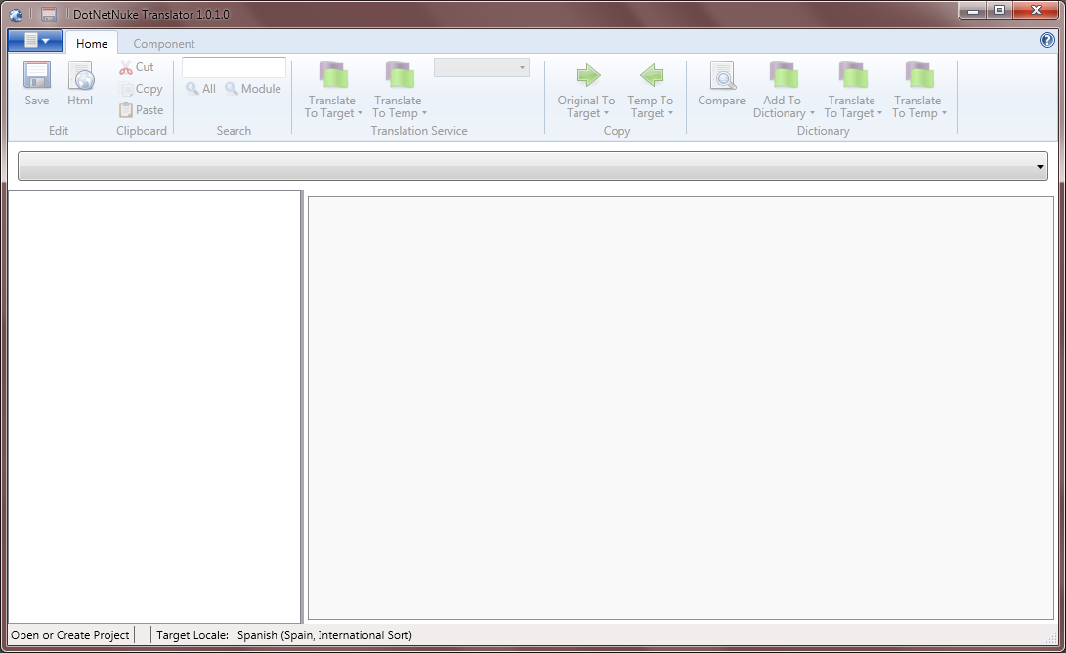

- Select New from the dropdown menu

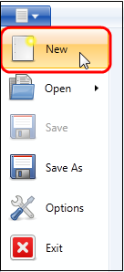

- Browse for your local DNN installation folder

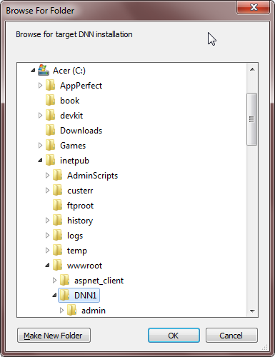

- Press OK

A new window will open where you can configure the DotNetNuke Translator settings.

Project Settings
You can customize the settings for the current project in this screen. This settings will be kept only for this particular project and will also be loaded while opening an already created project.

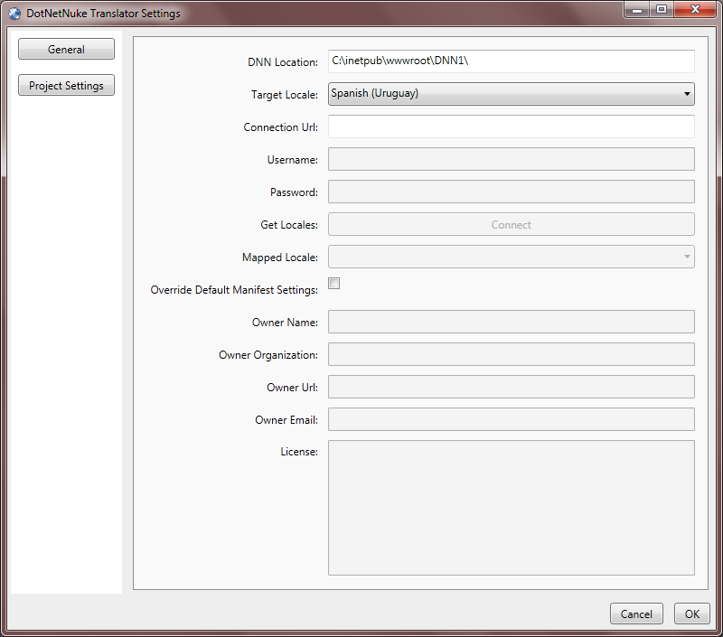

    - DNN Location: Is the root folder of your local installation of DotNetNuke.
    - Target Locale: The locale the Editor will create the RESX file for.
    - Connection URL: This is the URL to the Localization Editor located on a remote DNN installation
    - Username: Your Username to connect to the remote installation
    - Password: Your Password to access to the remote installation
    - Get Locales: Connects to the remote installation to retrieve the locales you have access to
    - Mapped Locale: The locale that the remote installation will be mapped to, for this project
    - Override Default Manifest Settings: If checked, The Language packs produced in this project will include these items
    - Owner Name: Package Owner Name
    - Owner Organization: Organization Name of the Language Pack owner
    - Owner URL: Language Pack Owner’s URL
    - Owner Email: Email address
    - License: Input any license information appropiate for the Language pack to be created

Before clicking OK Button, please review the General project options by selecting the general tab.

General Settings
This tab allows you to configure the DotNetNuke Transaltor general settings. These settings will affect all the DotNetNuke Translator projects.

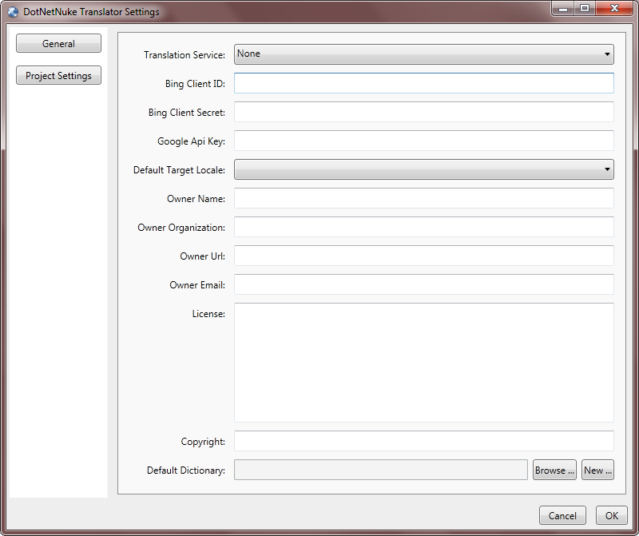

- Translation Service: This is the automatic translation service to use. Up to now services included are Google and Bing. You can also choose none if no automatic translation service is to be used.
- Bing Client ID: Client ID key code provided by Microsoft Bing translation services when you contract for their service.
- Bing Client Secret: This is a unique client code provided by Microsoft Bing translation services that along with the Client ID key allows the program to connect and retrieve the information from the translation services.
- Google API Key: If you are using Google translation services, the key provided by Google when purchasing the translation services must be pasted into this field.
- Default Target Locale: Point this to the default locale you will be using for localization
    - Owner Name: Package Owner Name
    - Owner Organization: Organization Name of the Language Pack owner
    - Owner URL: Language Pack Owner’s URL
    - Owner Email: Email address
    - License: Input any license information appropiate for the Language pack to be created
    - Default Dictionary: Allows you to choose an already created dictionary or to create a new one based on your current translation.

Open RESX Files to edit

Once all the RESX files are finished loading, the DotNetNuke Translator main screen will open displaying the content of all folders present in your local DNN installation.

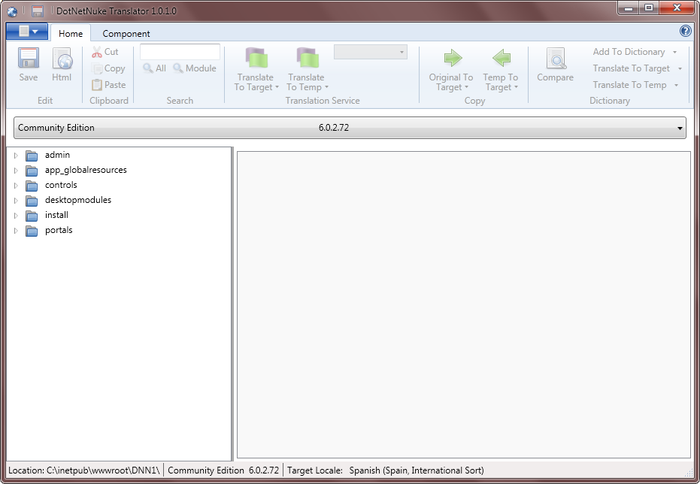

Select the DNN Module you want to translate from the drop-down list located under the menu bar. For this example, we will choose the Interzoic Accord LMS module.

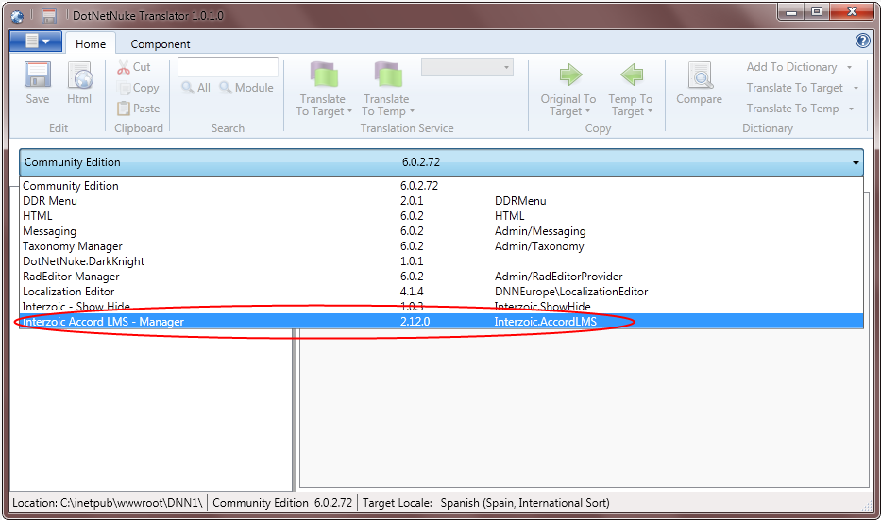

The folder view will refresh to display the list of folders contained within the selected module.

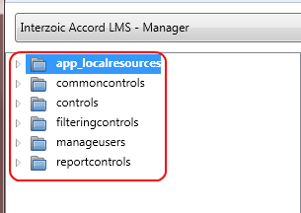

To open the folders, double click on them, alternatevily you can click the arrow icon next to them.

Once the folder is open all RESX files contained in it will be listed. In order to open each file, double click on it.

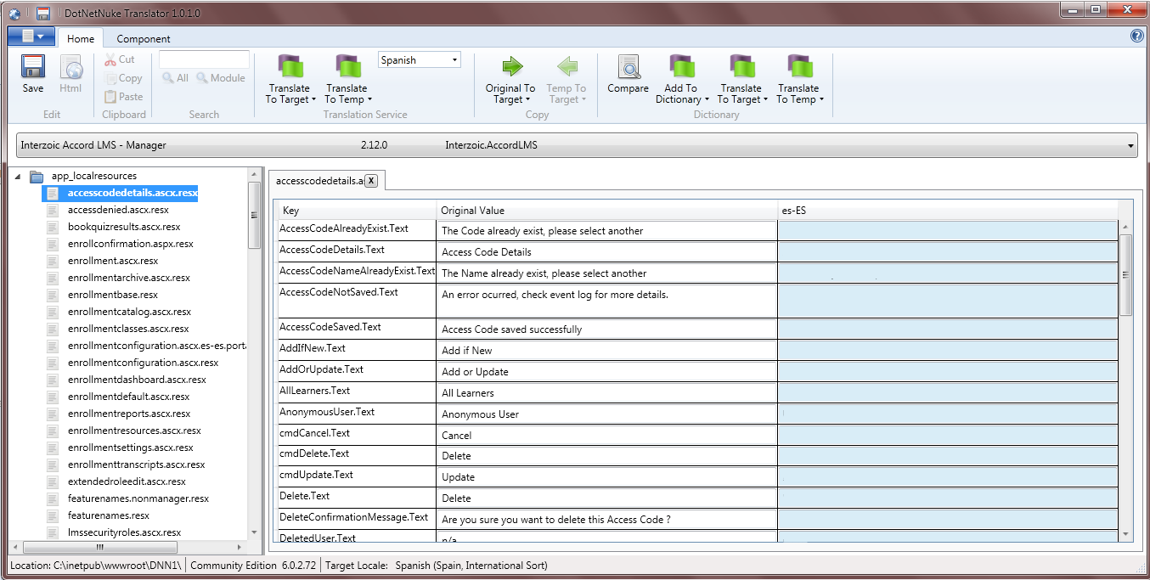

The content of each RESX file is displayed to shown the original value column (left side) and the localized value column (right side). Initially the right column (es-ES in this case) shows completely blank.

Using the Automatic Translation services
The Automatic Translation feature, is built to use both the Google API translation services and Bing (Microsoft) translation services. A key is required to use any of these services which can be purchased directly with the provider. Please refer to the General Settings chapter for details on how to set this up.

The Automatic Translation controls are located on the top of the window, grouped under “Translation Service”

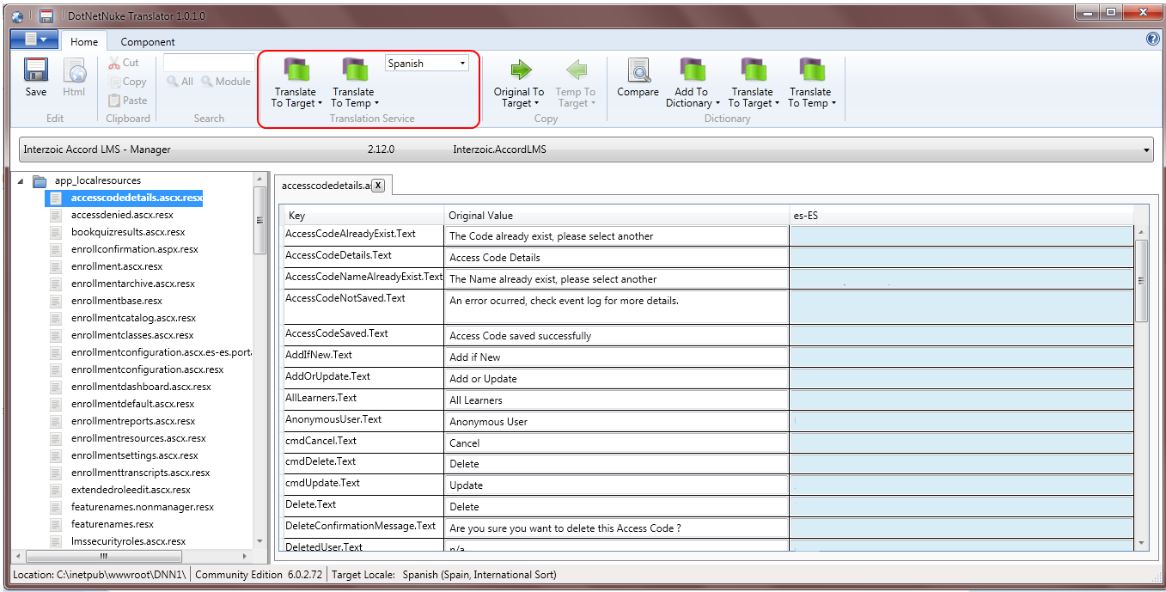

Select the desire destination language from the dropdown menu.This field is automatically populated based on the default culture selected while creating the project.

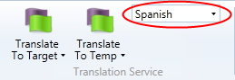

The Translate to Target button, translates one single line of text at the time. You can use this option when there are only a few text strings to be translated or when you want to review each translation individually. However, if you desire to translate several text strings at the same time, you can click on the down arrow icon next to “Translate to Target” to display the different options.

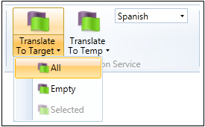

- All: Translates All the strings present in the resx file
- Empty: Translates only the Empty lines
- Selected: Translates only the selected strings

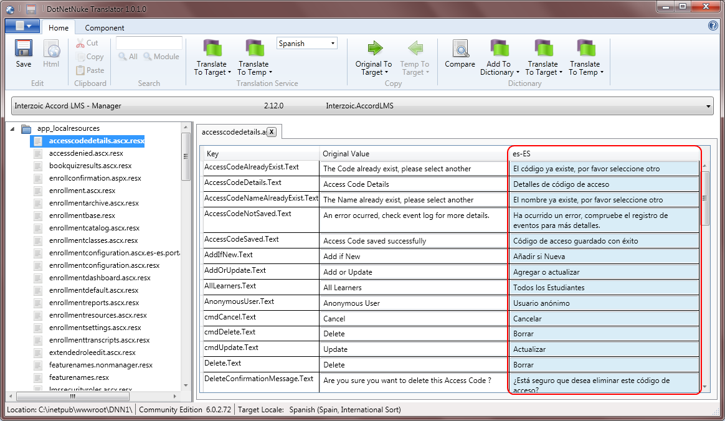

  - Click Save to store your current progress.

Creating a Language Pack
After all your updates are finished, you can create a .ZIP file containing all the modified .RESX files. This will help you in getting the language packs installed in any remote site you desire.

On the DotNetNuke Translator main screen:

- Switch over to Component Tab

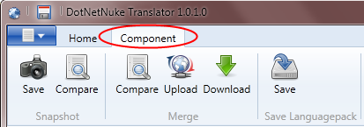

- Under Save Languagepack menu group, Click Save.

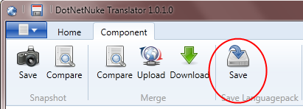

- Choose the location where you want to save your file. Additionaly you can change the package name.

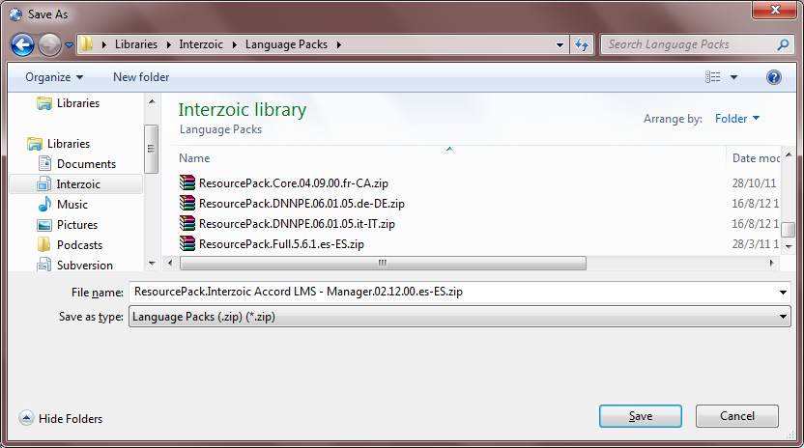

- Click Save

Dictionary
Once a Translation for a specific language is done, you can choose to add those to your personal “translation list”. This feature comes in useful when the same line of text is present in various instances. This way translation can be done directly from within the application and there is no need to use the remote translation services (Google, Bing)

Add to Dictionary
Once you have the translated fields, either by using the automating translation or by manually editing the fields, you can add these phrases or words to you “personal” dictionary.

There are two different options to add words or phrases to you custom dictionary. You can add all translated words or just the selected ones.

In the following example we will add just a selected word.

- Select the desire word from the destination culture column
- Go to Dictionary menu
- Click the down arrow icon next to “Add to Dictionary”
- Click Selected

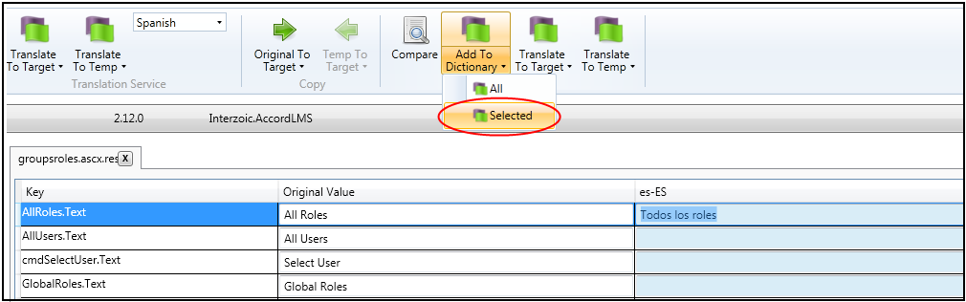

Translate to Target
Once the words are added to the Dictionary, you can use it to translate all those words that are equal to the ones already added. This will translate the sentences without the need to connect to any remote translation service.

For this example we have already added a few strings to our “custom” dictionary.

- Go to Dictionary menu
- Click the down arrow icon next to “Add to Dictionary”
- Click All

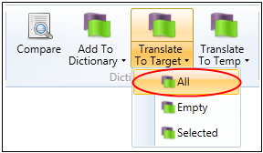

All those words that are found in the dictionary will be placed next to its corresponding translation

